AVC704

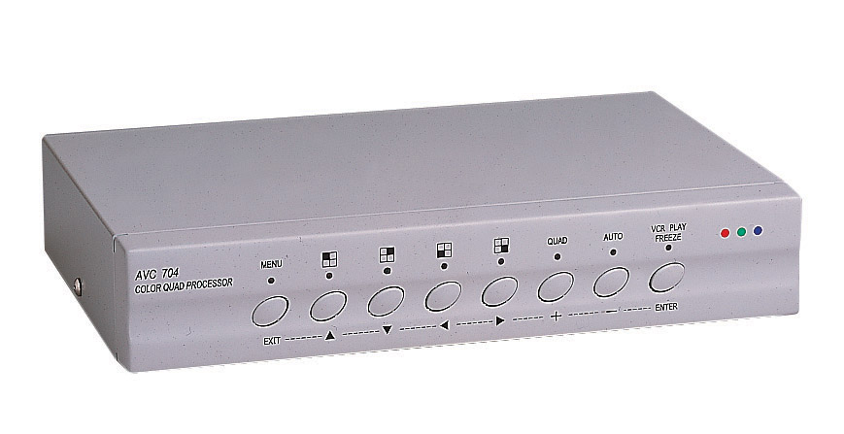
Color Quad Processor
Features

Video Input
- Connect up to 4 +1 (VCR) cameras

Video Output
- Quad and switch video output

Real Time & High Resolution
- Real time refresh rate
(NTSC:30 frame/sec;
PAL: 25 frame/sec.)
- 720(H) x 480(V) (NTSC)
720(H) x 576 (V) (PAL)
- 16.7 million true color

Multi-function
- Independent full screen
- Auto sequential switching
- System auto detection (NTSC/PAL)
- Video adjustable on channels
- Video loss indication
- Freeze feature

VCR Play Zoom Back
- Alarm I/O to cooperate with security system
- OSD user friendly (On Screen Display)

Specification

Video input port | 4 +1 (VCR) cameras
Video output port | 1 switch & 1 quad output
Alarm input | 4
Alarm output | 1
Alarm duration | 1 - 99
Camera Title | 10 characters
Time / Date set | Built-in real time clock
Dwell Time | 1 - 30
RS-232 port | Yes
Load impedance | 75Ω
Operating environment | 10~80%RH, 0ºC~50ºC
Power source | DC 12V ± 10%, 500mA
Power consumption | 6W maximum
Dimensions (mm) | 240(W) x 44.4 (H) x 151 (D)
Weight | 1,300g

- Design and specifications are subject to change without notice.

